**Super Shop Management System**

**Group Member:**

1.MD. MAHEDI HASAN CHOWDHURY 22-46580-1

2.RANGON KUMAR SHAHA 22-46585-1

3.DIP ACHORJEE SHOKAL 22-46788-1

4.MD. REZWAN MUJAHID RUDRO 22-46802-1

**Functionality and Features**

**Customer's Perspective:**

1. **Authentication Login:**
   * A customer visits the Super Shop Management System and logs in using their unique username and password.
2. **Registration:**
   * New customers can register by providing necessary details like name, contact information, and address.
3. **Browsing Products:**
   * Once logged in, customers can explore the products menu categorized by product types such as groceries, electronics, clothing, etc.
4. **Placing an Order:**
   * Customers can add desired products to their virtual shopping cart and proceed to the checkout.
5. **Confirmation of Order:**
   * Before finalizing the order, customers review their selected items, quantities, and total price. They confirm the order to proceed.
6. **Payment Options:**
   * After confirming the order, customers can choose from various payment options such as credit/debit card, cash on delivery, or digital wallets.
7. **Product Review & ratings:**
   * After successfully purchasing a product, customers have the option to leave a review and provide feedback on the product and overall service.

**Admin's Perspective:**

1. **Authentication Login:**
   * The admin logs into the Super Shop Management System using their credentials.
2. **Order Approval:**
   * The admin reviews incoming orders, verifies payment, and approves the orders for processing.
3. **Customer Reviews and Comments:**
   * The admin can access and view all customer reviews and comments. They may respond to customer feedback and take necessary actions for improvement.
4. **Product Management:**
   * Admin can add new products to the inventory, specifying product details, images, and assigning them to appropriate product types/categories.
5. **Product Type Management:**
   * Admin has the ability to create, modify, or delete product types/categories for better organization.
6. **Supplier Details:**
   * Admin can access a list of suppliers, view their details, and manage relationships with suppliers. This includes adding new suppliers or updating existing information.
7. **Payment Details:**
   * The admin has access to payment details, ensuring transparency in financial transactions. This includes tracking payments received from customers and payments made to suppliers.
8. **System Monitoring:**
   * The admin monitors the overall system performance, ensuring smooth operation and addressing any technical issues promptly.

**Case Study**

In the realm of the Super Shop Management System, a seamless shopping experience unfolds for both customers and administrators. Customers embark on their journey by securely authenticating their identities, ensuring a personalized interaction with the system. Newcomers find a welcoming embrace through a straightforward registration process, unlocking a world of possibilities. Navigating the digital aisles of the products menu, customers revel in the freedom to order items of their choice. Upon confirmation of their selected products, a diverse array of payment options unveils itself, offering a secure and flexible transaction process. Post-purchase, customers are encouraged to share their thoughts and experiences by leaving reviews, contributing to a vibrant feedback loop. Behind the scenes, the administrator wields authority over order approval, ensuring a smooth fulfillment process. The admin's purview extends beyond orders to encompass a holistic view of customer sentiments through reviews and comments. They play a pivotal role in expanding the product catalog by seamlessly adding new products and managing product types. Additionally, the administrator maintains a keen eye on supplier details and payment records, fostering transparency and efficiency in the supply chain. The Super Shop Management System thus emerges as a digital haven, harmonizing customer satisfaction with administrative prowess in the retail landscape.

**Schema Diagram**

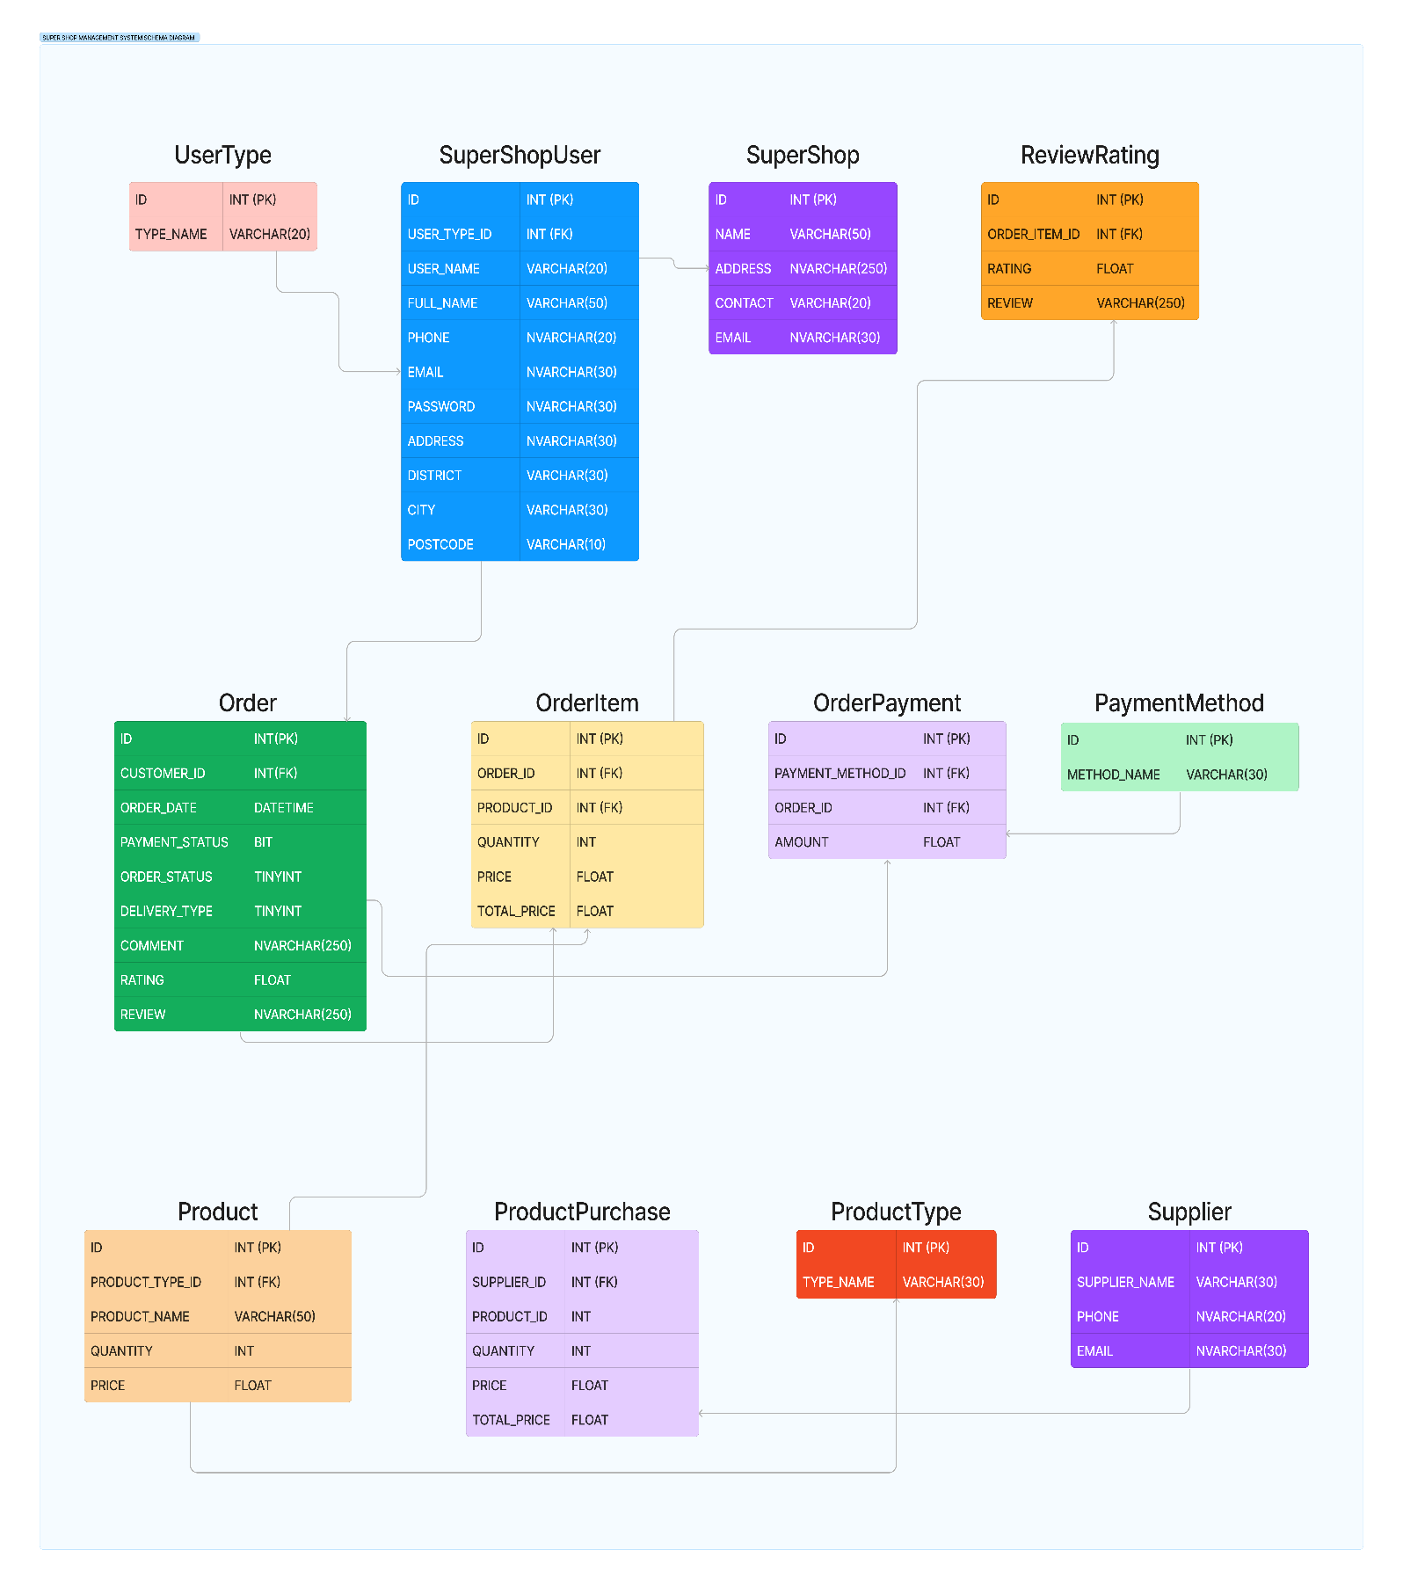

**Transition Diagram (UI)**

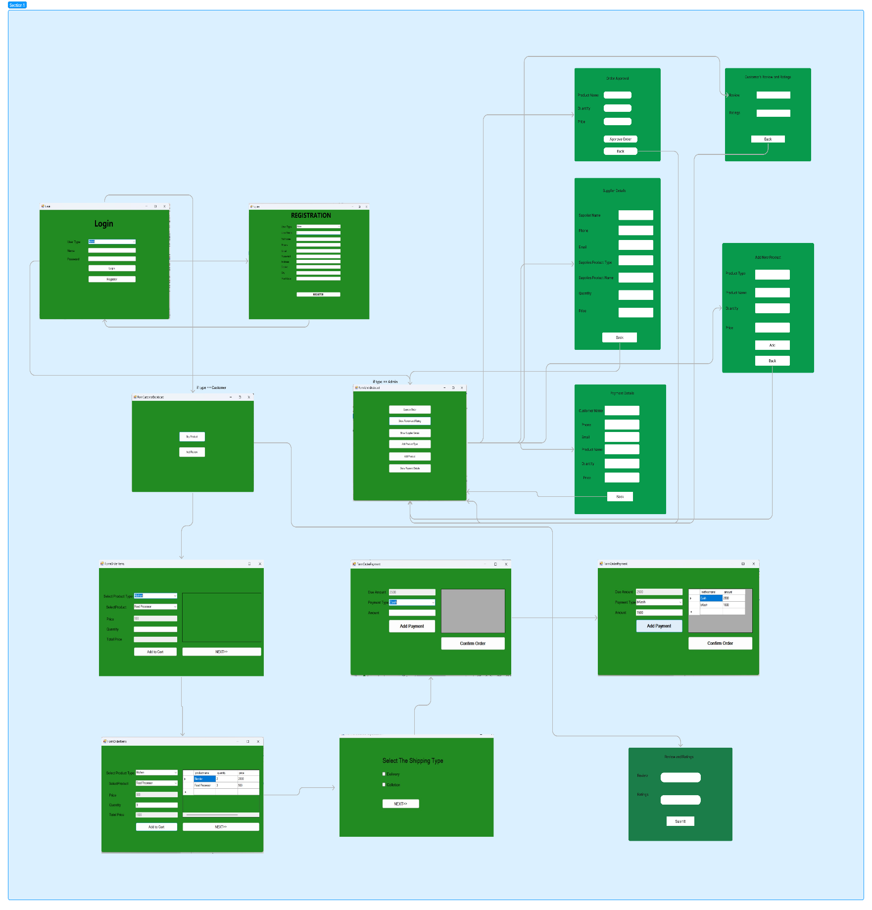

**Transition Diagram**

